Database Kendaraan KARENT

* Kecil

1. Toyota Agya

Kapasitas = 5

Transmisi = Automatic

Base Price = Rp. 350.000

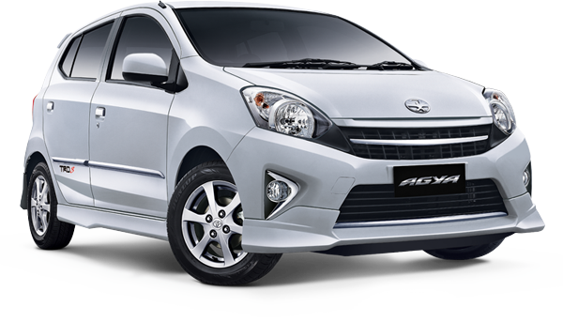

1. Daihatsu Ayla

Kapasitas = 5

Transmisi = Automatic

Base Price = Rp. 350.000

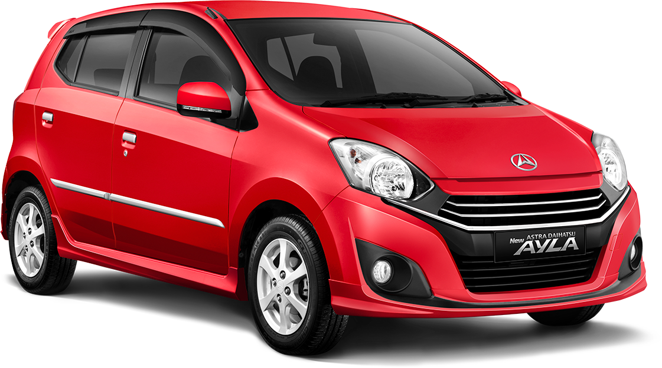

1. Honda Brio

Kapasitas = 5

Transmisi = Manual

Base Price = Rp. 325.000

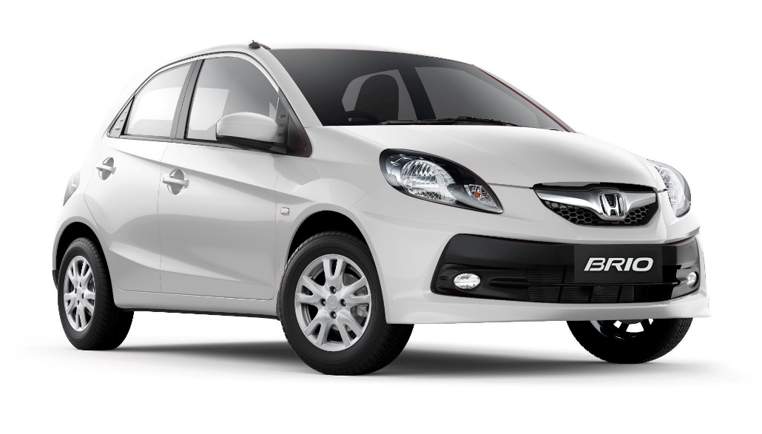

1. Nissan March

Kapasitas = 5

Transmisi = Automatic

Base Price = Rp. 350.000

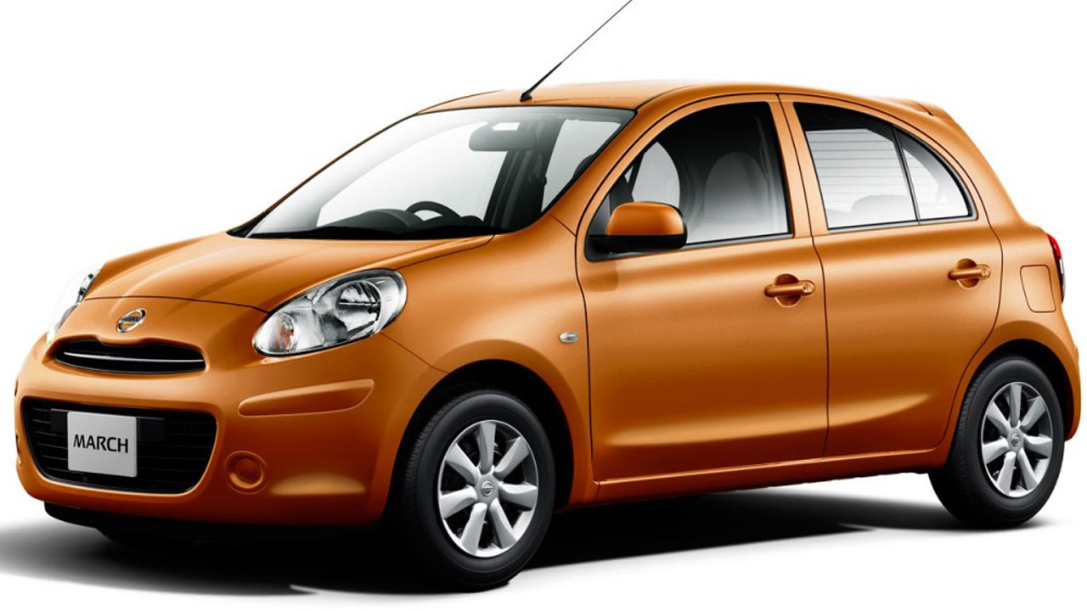

1. Toyota Vios

Kapasitas = 5

Transmisi = Automatic

Base Price = Rp. 400.000

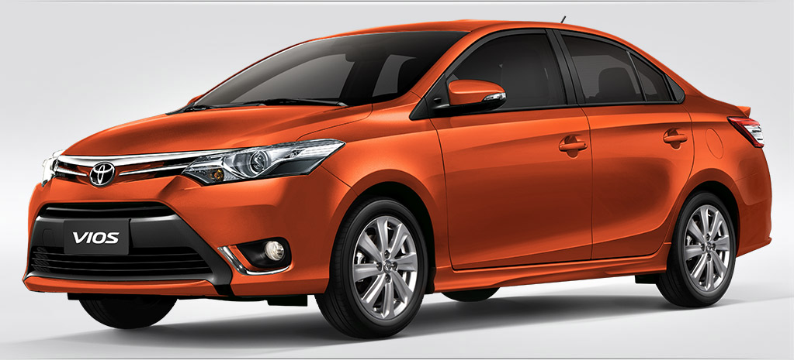

1. Mitsubishi Lancer

Kapasitas = 5

Transmisi = Manual

Base Price = Rp. 400.000

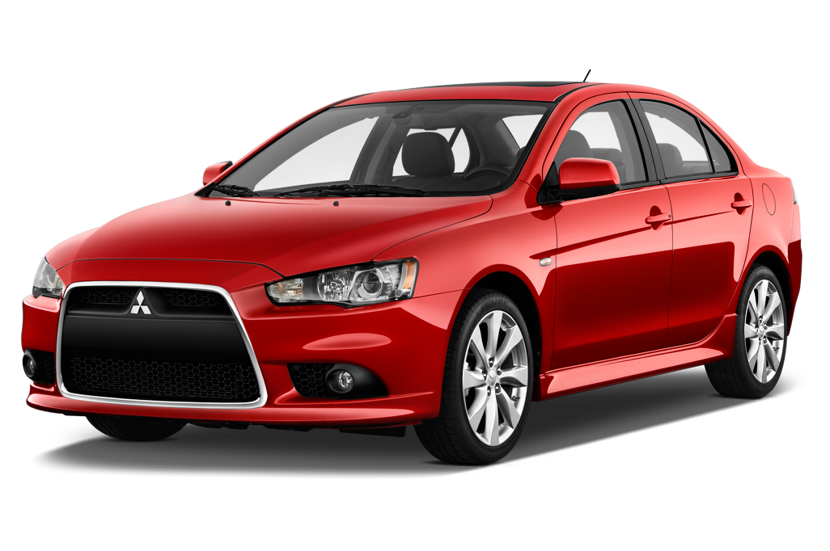

* Sedang

1. Toyota Avanza

Kapasitas = 8

Transmisi = Automatic

Base Price = Rp. 600.000

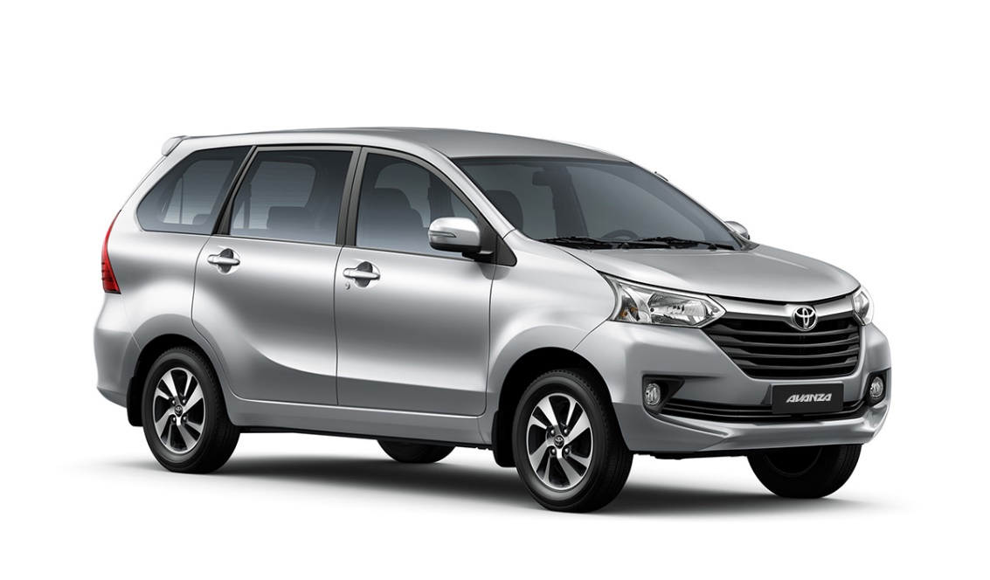

1. Daihatsu Xenia

Kapasitas = 8

Transmisi = Automatic

Base Price = Rp. 600.000

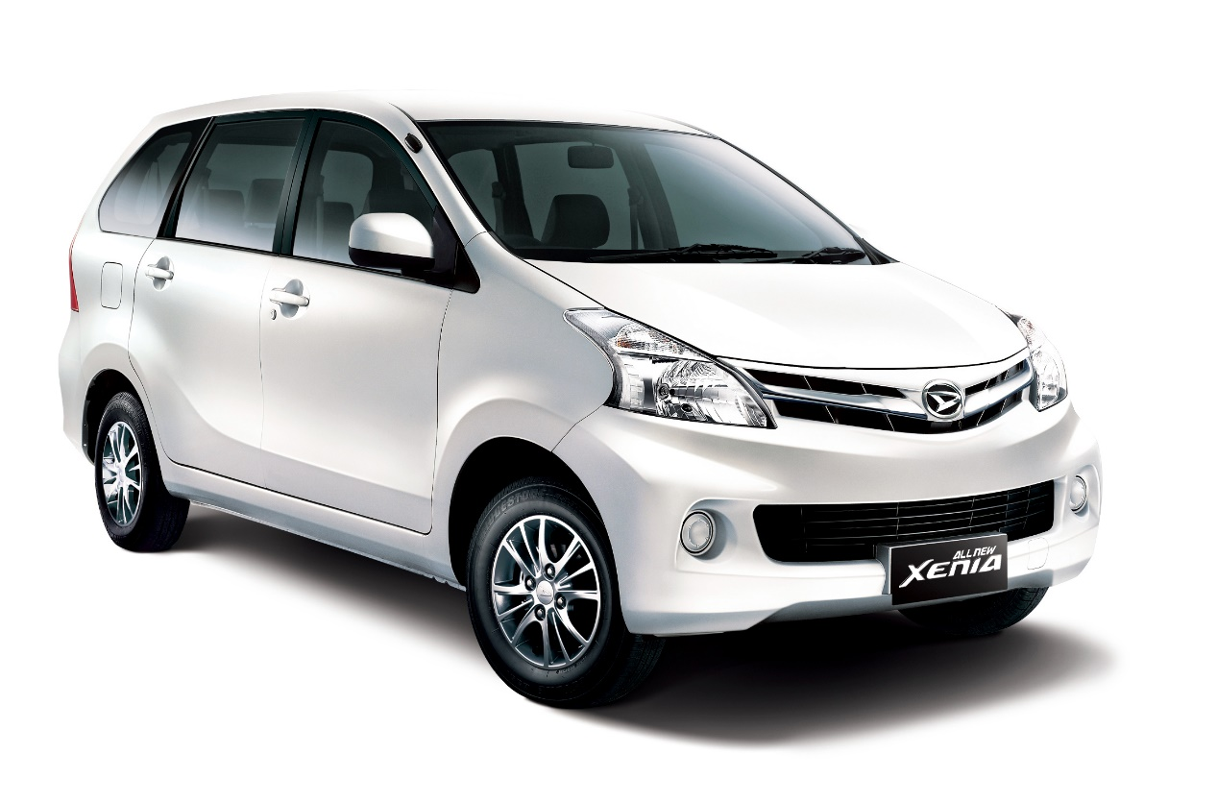

1. Honda Mobilio

Kapasitas = 8

Transmisi = Manual

Base Price = Rp. 550.000

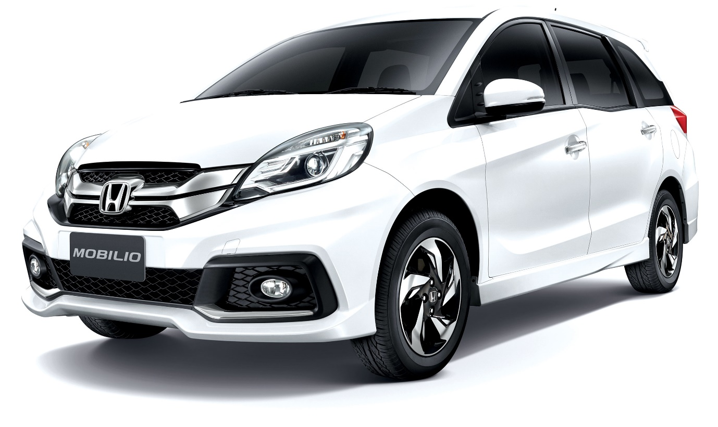

1. Nissan Livina

Kapasitas = 8

Transmisi = Manual

Base Price = Rp. 550.000

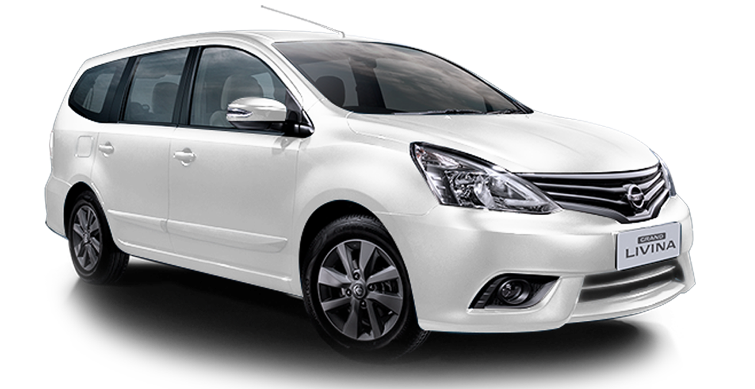

1. Daihatsu Gran Max

Kapasitas = 8

Transmisi = Manual

Base Price = Rp. 600.000

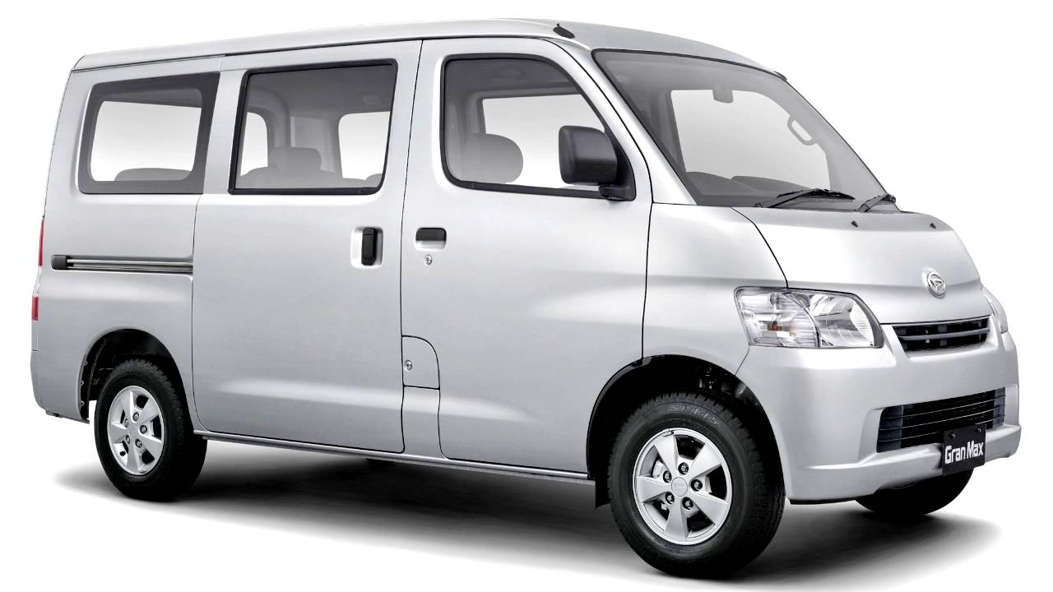

1. Toyota Innova

Kapasitas = 8

Transmisi = Automatic

Base Price = Rp. 700.000

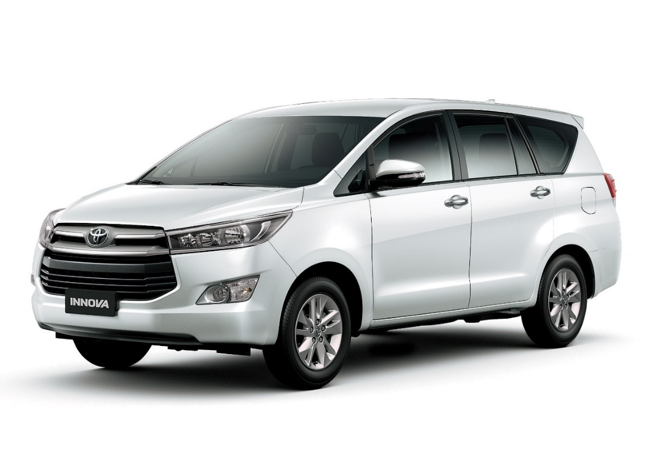

1. Toyota Fortuner

Kapasitas = 8

Transmisi = Manual

Base Price = Rp. 750.000

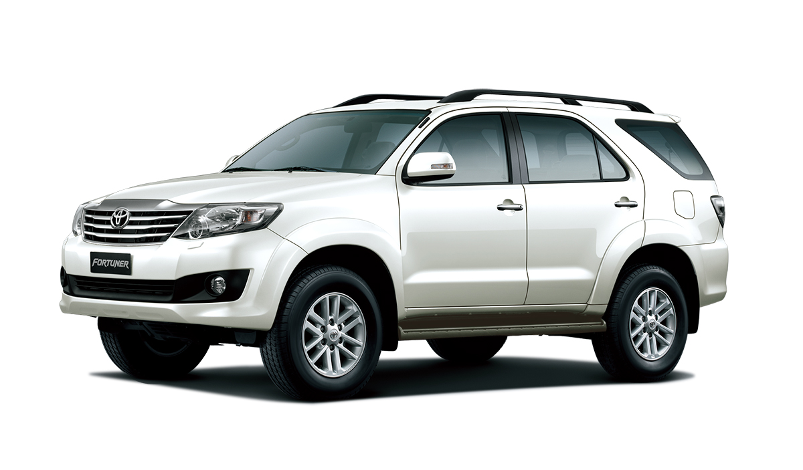

* Besar

1. Isuzu Elf Short

Kapasitas = 10

Transmisi = Manual

Base Price = Rp. 850.000

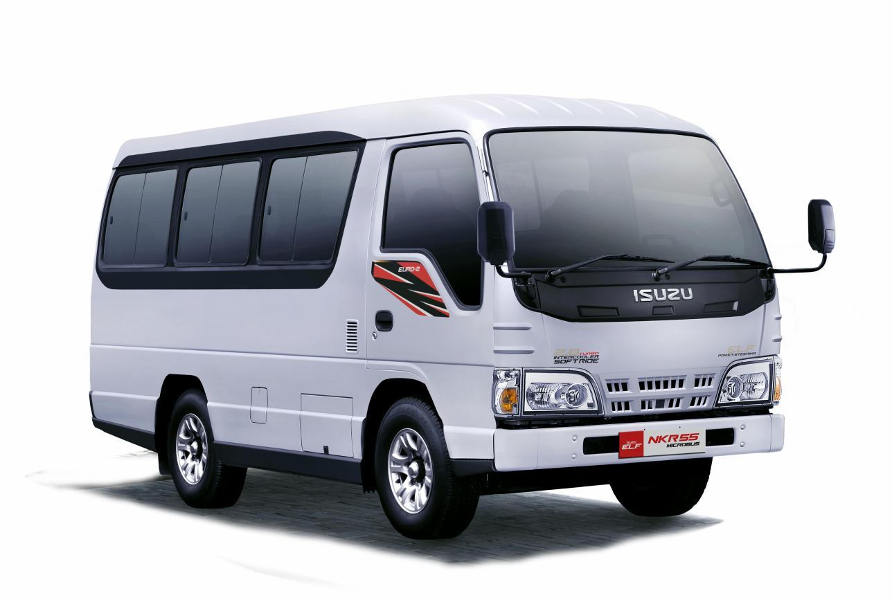

1. Toyota Hiace

Kapasitas = 14

Transmisi = Manual

Base Price = Rp. 900.000